Steps to run the file in Turbo C IDE-

1. Download Turbo C file

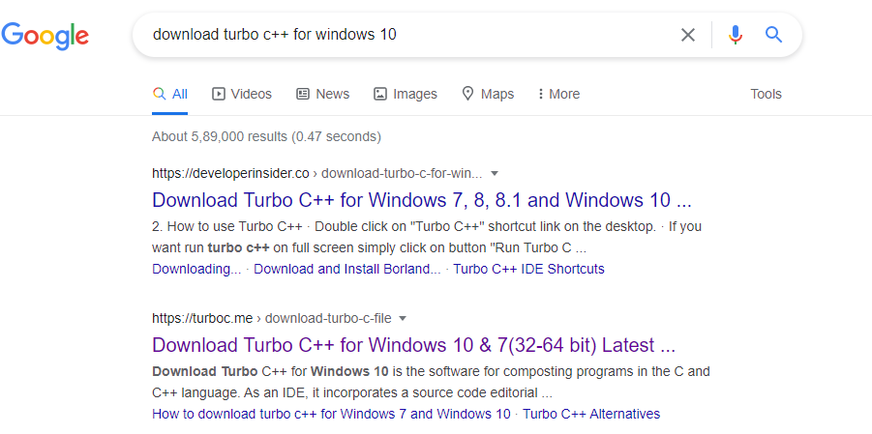

1. Run the set and install the file

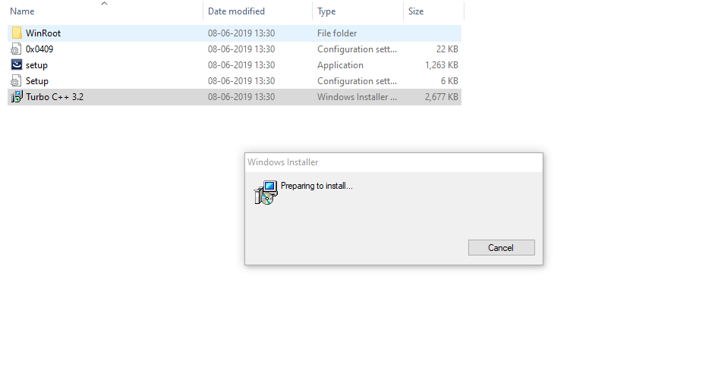

1. On successful installation, this dialog box will appear

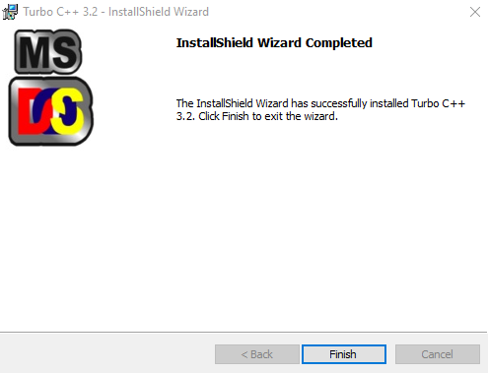

1. Open the IDE, go to File->Open->your file

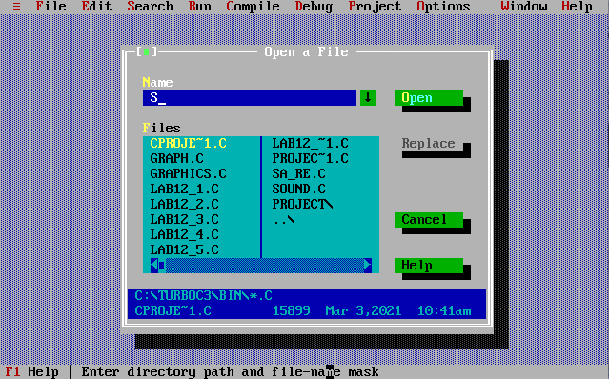

1. To run the file, go to Run->Run, it will simultaneously compile the file for errors

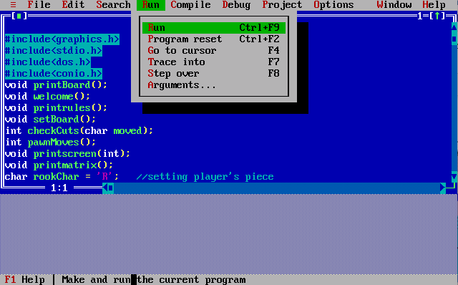

1. The program runs with graphic and sound output

